- Install tabpy in a python environment
- Run the tabpy server
- Enable analytic extension connection
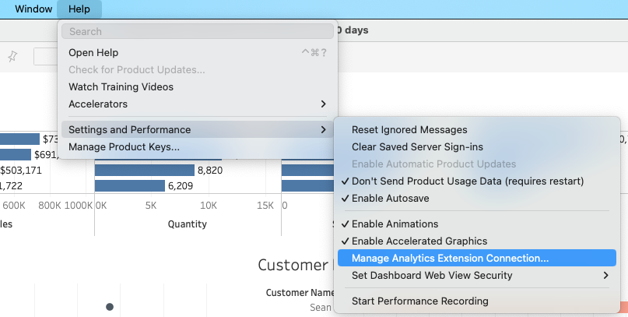

- Connect to your tabpy server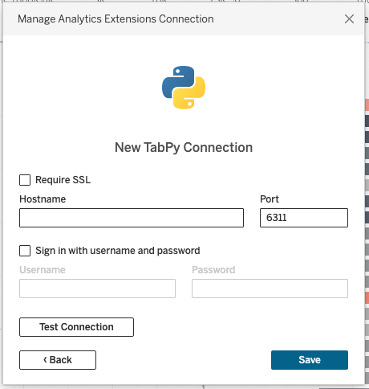
- Test the connection by inserting a calculated field using the SCRIPT_xxx functions.
  - SCRIPT_INT('return _arg1', MAX([Profit]))
- Follow instructions from the official doc to create functions that are injected to the tabpy server.
  - https://tableau.github.io/TabPy/docs/tabpy-tools.html
  - Example:
  - SCRIPT_REAL("return tabpy.query('add', _arg1, _arg2)['response']", AVG([Discount]), AVG([Sales]))

Code to deploy function to tabpy server.
from tabpy.tabpy_tools.client import Client

client = Client('http://localhost:9004/')

def add(x, y):
import numpy as np
print(x, y)
return np.add(x, y).tolist()

client.deploy('add', add, 'Adds two numbers x and y')

